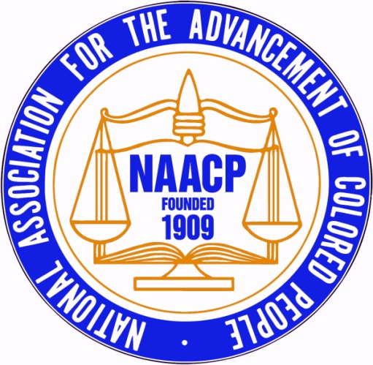 |  |  | Bond/Chandler Memorial Scholarship  2021 Scholarship Application
First Name: |  |  |  |  | Last Name:
Date of Birth: |  |  |  |  | Contact Number:
E-mail:
Street Address: |  |  |  |  | City, State, Zip
Parent/Guardian #1 First and Last Name
Street Address: |  |  |  |  | City, State, Zip
E-mail:
Contact Number:
Parent/Guardian #2 First and Last Name
Street Address: |  |  |  |  | City, State, Zip
E-mail:
Contact Number:
Current Academic Status:
High School Name:
High School Address:
Reading & Writing SAT Score:
Math SAT Score:
Cumulative GPA:
Class Size:
Class Rank:
Have you taken AP Classes? |  |  |  |  | How many?
Have you taken College Courses? |  |  |  |  | How many?
College Acceptances Received (list all):
College you are attending in Fall 2021
Enrollment type: □Full-Time □ Part-Time |  |  |  |  | Major:
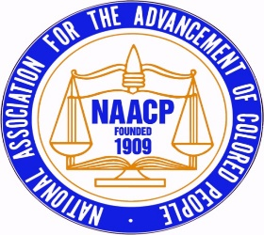

2021 Scholarship Application
Requirements and Directions

Thank you for your interest in applying to the Bond/Chandler Memorial Scholarship. Please carefully read the requirements below for submitting an application. The Harford County NAACP Chapter will award two (2) scholarships this academic school year.
REQUIREMENTS TO APPLY FOR A 2021 SCHOLARSHIP:

1. | Each applicant is required to submit ALL of the following documents:
 | a. | a completed 2021 Scholarship Application form
 | b. | a current high school transcript in PDF form (college transcript for current college students),
 | c. | two letters of recommendation in PDF form, and
 | d. | Completed scholarship application forms for each specific scholarship you are applying for.
2. | Applications are only accepted by e-mail; all required documents must be sent together in one e-mail and must be sent to jthornton@thorwoodreg.com.
3. | Applicant must be a high school senior (Public or Private School) in Harford County.
Bonus Consideration
 | Applicant should consider becoming a member of the NAACP.
4. | Applicant must plan to enroll in an undergraduate program or to pursue a certificate in an approved career certification program.
5. | If selected, student must provide proof of admission to an accredited college.
6. | Applicant must be graduating from high school in May 2021.
7. | Your e-mail with all required documents must be received by 12 noon on Monday, April 26, 2021.

